***Experiment 8 Output***

Data aggregation techniques were **implemented** to generate **summarized views** of large datasets, enhancing reporting and analytical efficiency.

***Total Sales Aggregation***

***Region Wise aggregation***

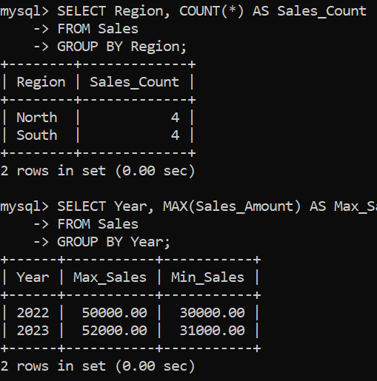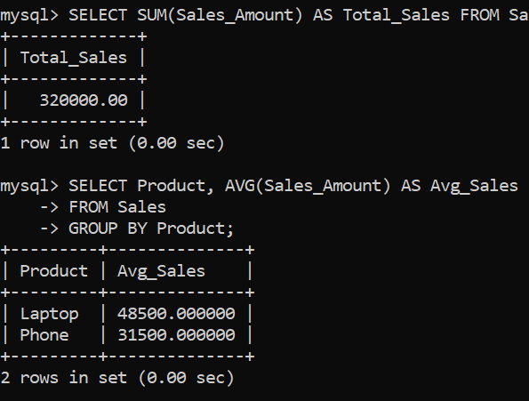

***Creating Tables***

***Fig 1: Sales aggregation on table***

***Fig 2: Min-Max Queries***

***Sales by Category***

***Regional-Yearly Aggregation***

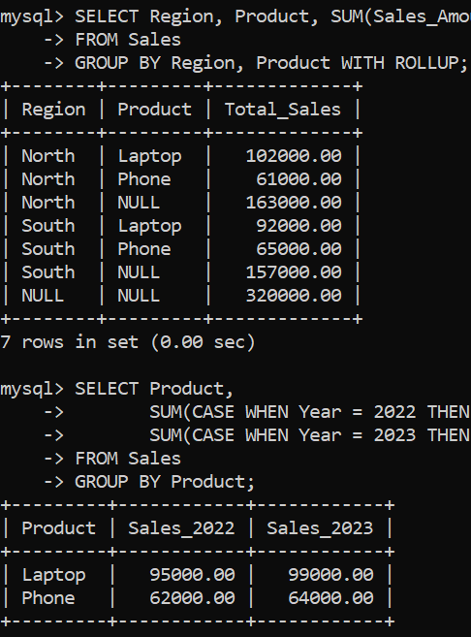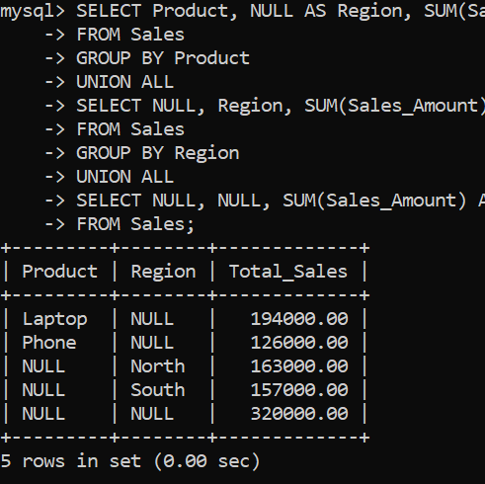

***Fig 4: Region and Yearly Aggregation by product Categories***

***Fig 3: Grouping Queries***